**Problem 1 :**

In a survey of university students, 64 had taken mathematics course, 94 had taken chemistry course, 58 had taken physics course, 28 had taken mathematics and physics, 26 had taken mathematics and chemistry, 22 had taken chemistry and physics course, and 14 had taken all the three courses. Find how many had taken one course only.

**Step 1 :**

Venn diagram related to the information given in the question:

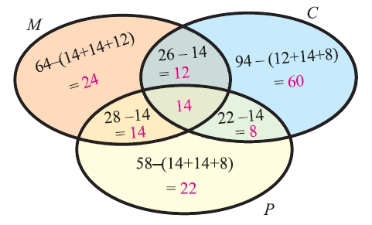

**Step 2 :**

From the venn diagram above, we have

No. of students who had taken only math  =  24

No. of students who had taken only chemistry  =  60

No. of students who had taken only physics  =  22

**Step 3 :**

Total no. of students who had taken only one course :

=  24 + 60 + 22

=  106

Hence, the total number of students who had taken only one course is 106.

**Problem 2 :**

In a group of students, 65 play foot ball, 45 play hockey, 42 play cricket, 20 play foot ball and hockey, 25 play foot ball and cricket, 15 play hockey and cricket and 8 play all the three games. Find the total number of students in the group (Assume that each student in the group plays at least one game).

**Step 1 :**

Venn diagram related to the information given in the question :

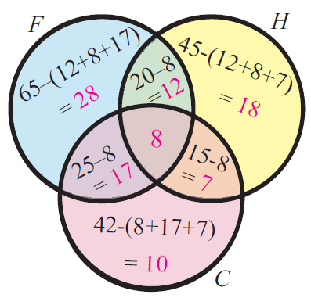

**Step 2 :**

Total number of students in the group :

=  28 + 12 + 18 + 7 + 10 + 17 + 8

=  100

So, the total number of students in the group is 100.

**Problem 3 :**

In a college, 60 students enrolled in chemistry,40 in physics, 30 in biology, 15 in chemistry and physics,10 in physics and biology, 5 in biology and chemistry. No one enrolled in all the three. Find how many are enrolled in at least one of the subjects.

**Solution :**

Let C, P and B represents the subjects Chemistry, Physics  and Biology respectively.

Number of students enrolled in Chemistry :

n(C)  =  60

Number of students enrolled in Physics :

n(P)  =  40

Number of students enrolled in Biology :

n(B)  =  30

No.of students enrolled in Chemistry and Physics :

n(CnP)  =  15

No.of students enrolled in Physics and Biology :

n(PnB)  =  10

No.of students enrolled in Biology and Chemistry :

n(BnC)  =  5

No one enrolled in all the three. So, we have

n(CnPnB)  =  0

The above information can be put in a venn diagram as shown below.

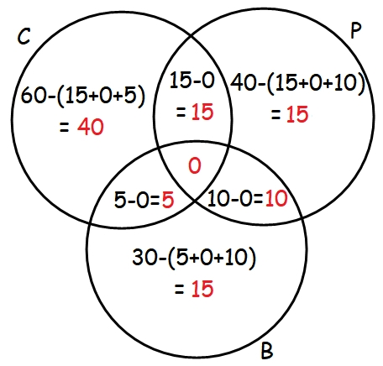

From, the above venn diagram, number of students enrolled in at least one of the subjects :

=  40 + 15 + 15 + 15 + 5 + 10 + 0

=  100

So, the number of students enrolled in at least one of the subjects is 100.